U4 – AT3 – Integrated Experiments
Machine Learning Laboratory
Decision Trees & Q-Learning
Experiment 1: Decision Tree Classification | Experiment 2: Reinforcement Learning (Q-Learning)
Name: S. Harish
Reg. No: 192511119
Course code/Name: CSA1717 – Artificial Intelligence

Experiment 1: Decision Tree Classification
Objective: Implement and evaluate a Decision Tree classifier on the Iris dataset using Python and scikit-learn.

(a) Data Loading, Pre-processing and Train/Test Split
The Iris dataset (150 samples, 4 numeric features, 3 balanced classes) was loaded using scikit-learn's built-in loader. A missing-value check was performed (the dataset contains none), and the target variable is already label-encoded as integers 0/1/2 corresponding to setosa, versicolor and virginica. The data was split 70:30 into training and testing sets using stratified sampling to preserve class balance.
"""
Experiment 1: Decision Tree Classification on the Iris dataset
"""
import pandas as pd
import numpy as np
from sklearn.datasets import load_iris
from sklearn.model_selection import train_test_split
from sklearn.tree import DecisionTreeClassifier, plot_tree, export_text
from sklearn.metrics import accuracy_score, confusion_matrix, classification_report
import matplotlib.pyplot as plt

RESULTS = {}

# ---------------------------------------------------------------
# (a) Load, pre-process, split
# ---------------------------------------------------------------
iris = load_iris()
df = pd.DataFrame(iris.data, columns=iris.feature_names)
df['species'] = iris.target
df['species_name'] = df['species'].map(dict(enumerate(iris.target_names)))

# Check missing values (Iris has none, but we show the standard check)
missing_report = df.isnull().sum()

# Encoding: target is already numeric (0,1,2) -> label-encoded via target_names mapping
# (species_name kept only for readability, species column used for modelling)

first_5 = df.drop(columns='species_name').head()
dtypes = df.dtypes

X = df[iris.feature_names]
y = df['species']

X_train, X_test, y_train, y_test = train_test_split(
X, y, test_size=0.3, random_state=42, stratify=y
)

RESULTS['first_5'] = first_5
RESULTS['dtypes'] = dtypes
RESULTS['missing'] = missing_report
RESULTS['shapes'] = (X_train.shape, X_test.shape)

# ---------------------------------------------------------------
Output — First 5 rows and data types
======================================================================
FIRST 5 ROWS
======================================================================
sepal length (cm) sepal width (cm) petal length (cm) petal width (cm) species
0 5.1 3.5 1.4 0.2 0
1 4.9 3.0 1.4 0.2 0
2 4.7 3.2 1.3 0.2 0
3 4.6 3.1 1.5 0.2 0
4 5.0 3.6 1.4 0.2 0

======================================================================
DATA TYPES
======================================================================
sepal length (cm) float64
sepal width (cm) float64
petal length (cm) float64
petal width (cm) float64
species int64
species_name str

======================================================================
MISSING VALUES PER COLUMN
======================================================================
sepal length (cm) 0
sepal width (cm) 0
petal length (cm) 0
petal width (cm) 0
species 0
species_name 0

Train shape: (105, 4), Test shape: (45, 4)
Result: All four features are numeric (float64) and the target is int64/categorical (str for the readable label). No missing values were found in any column, so no imputation was required. The 105 training / 45 testing split preserves the original 50/50/50 class distribution.

(b) Building the Decision Tree (Gini Index)
A DecisionTreeClassifier was trained using the Gini Index as the splitting criterion (criterion='gini'), which is the scikit-learn default and measures node impurity — the tree greedily selects, at every node, the feature/threshold pair that produces the largest reduction in Gini impurity between parent and children.
clf = DecisionTreeClassifier(criterion='gini', max_depth=4, random_state=42)
clf.fit(X_train, y_train)
tree_text = export_text(clf, feature_names=list(X.columns))
Output — Tree structure (text form)
|--- petal length (cm) <= 2.45
| |--- class: 0
|--- petal length (cm) > 2.45
| |--- petal width (cm) <= 1.55
| | |--- petal length (cm) <= 4.95
| | | |--- class: 1
| | |--- petal length (cm) > 4.95
| | | |--- class: 2
| |--- petal width (cm) > 1.55
| | |--- petal width (cm) <= 1.70
| | | |--- sepal width (cm) <= 2.85
| | | | |--- class: 1
| | | |--- sepal width (cm) > 2.85
| | | | |--- class: 2
| | |--- petal width (cm) > 1.70
| | | |--- petal length (cm) <= 4.85
| | | | |--- class: 1
| | | |--- petal length (cm) > 4.85
| | | | |--- class: 2
Visualised Decision Tree
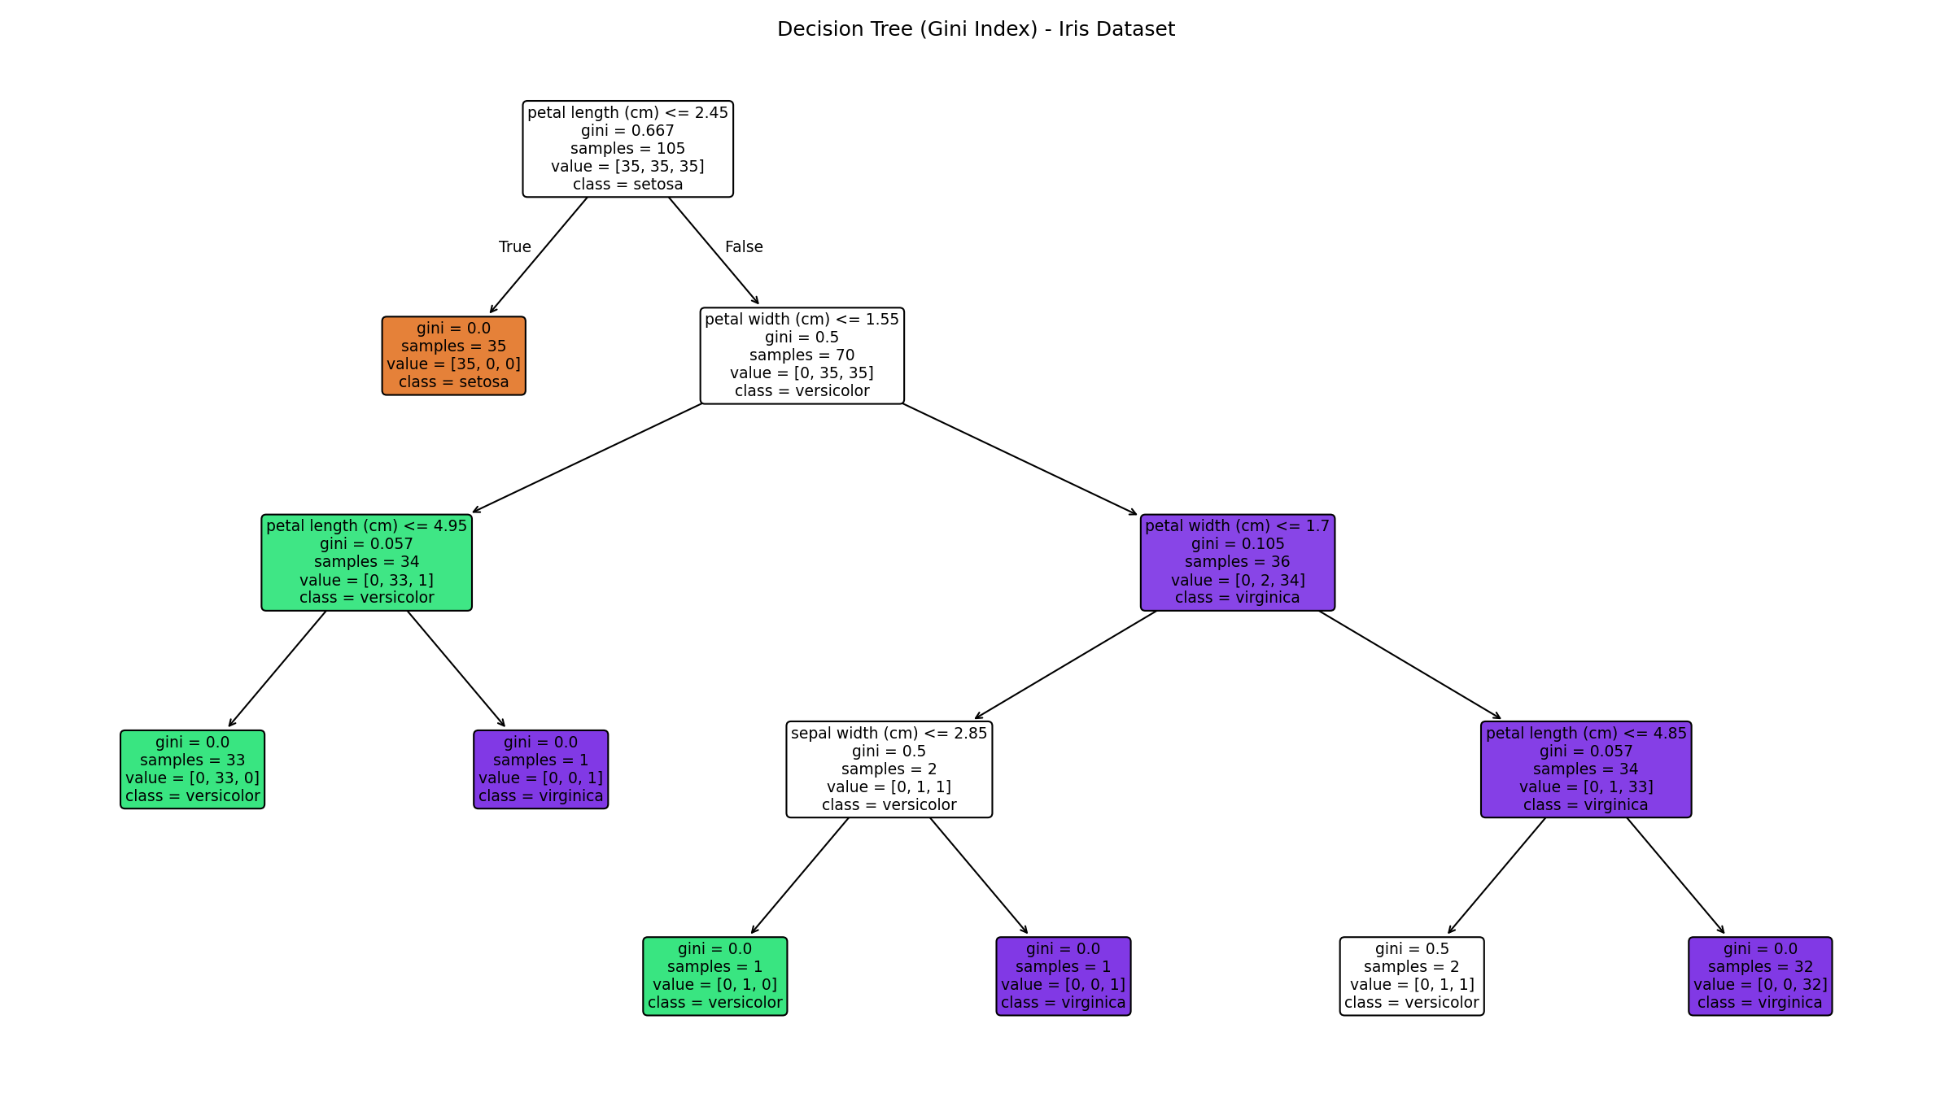

Root Node Identification & Justification
Property | Value
Root splitting feature | petal length (cm)
Split threshold | ≤ 2.45 cm
Gini impurity at root | 0.667 (maximum for 3 balanced classes)
Samples at root | 105 (entire training set)
Feature importance (petal length) | 0.549 (highest of all 4 features)

Justification: The Decision Tree algorithm selects the root split by exhaustively evaluating every feature and threshold on the full training set and choosing the one that yields the greatest Gini impurity reduction (equivalently, the greatest weighted purity gain in the resulting child nodes). "petal length (cm)" was selected because splitting at 2.45 cm perfectly isolates the setosa class from the other two (a pure child node, Gini = 0), which is the single most discriminative split available in the dataset — no other single threshold on any feature separates a class this cleanly. This is corroborated by scikit-learn's feature_importances_, where petal length (0.549) and petal width (0.436) together account for over 98% of the total impurity reduction across the whole tree, while sepal length contributes 0.

(c) Model Evaluation
y_pred = clf.predict(X_test)
acc = accuracy_score(y_test, y_pred)
cm = confusion_matrix(y_test, y_pred)
report = classification_report(y_test, y_pred, target_names=iris.target_names)
Output — Accuracy, Confusion Matrix, Classification Report
Accuracy: 0.8889

Confusion Matrix (rows=actual, cols=predicted):
[[15 0 0]
[ 0 12 3]
[ 0 2 13]]

Classification Report:
precision recall f1-score support

setosa 1.00 1.00 1.00 15
versicolor 0.86 0.80 0.83 15
virginica 0.81 0.87 0.84 15

accuracy 0.89 45
macro avg 0.89 0.89 0.89 45
weighted avg 0.89 0.89 0.89 45
Confusion Matrix (visual)
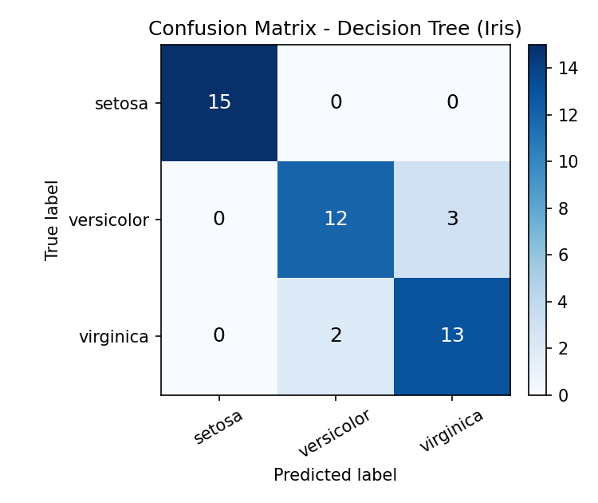

Misclassified Instances
Sample idx | Petal length | Petal width | Actual | Predicted
56 | 4.7 | 1.6 | versicolor | virginica
138 | 4.8 | 1.8 | virginica | versicolor
85 | 4.5 | 1.6 | versicolor | virginica

Performance Commentary
- Overall accuracy on the held-out test set was 88.9% (40/45 correct).
- Setosa was classified with perfect precision and recall (1.00), consistent with the root-node split completely isolating it.
- All 5 errors occurred between versicolor and virginica — these two classes overlap in feature space (petal length ~4.5–5.0 cm and petal width ~1.6–1.8 cm form a transition zone), which is a well-known characteristic of the Iris dataset.
- Example: sample 56 has petal length 4.7 cm / width 1.6 cm — just past the petal-width ≤ 1.55 boundary used deep in the tree, so it was pushed into the virginica branch despite being versicolor.
- A shallower/limited max_depth (4) was used to reduce overfitting; a fully grown tree would likely reach ~97-100% training accuracy but risks memorising noise at the versicolor/virginica boundary.

Experiment 2: Reinforcement Learning – Q-Learning
Objective: Implement Q-Learning for a 4×4 Grid World and observe the agent's learned policy.

(a) Environment Definition
Element | Definition
Grid size | 4 × 4 = 16 states (numbered 0–15, row-major)
Actions | Up, Down, Left, Right (4 discrete actions per state)
Start state | State 0 (top-left)
Goal state | State 15 (bottom-right) — reward +10, episode ends
Obstacle states | States 5, 7, 11 — reward −5, episode continues
Step reward | −1 for every other move (encourages shortest path)
Learning rate (α) | 0.1
Discount factor (γ) | 0.9
Exploration rate (ε) | 0.2 (ε-greedy action selection)

The Q-table is a 16 × 4 matrix initialised to all zeros, i.e. Q(s,a) = 0 for every state-action pair before learning begins.
ACTIONS = ['Up', 'Down', 'Left', 'Right']
Q = np.zeros((16, 4))
ALPHA, GAMMA, EPSILON = 0.1, 0.9, 0.2

def step(state, action):
# deterministic transition on the grid, clipped at boundaries
...
if next_state == GOAL_STATE: return next_state, 10, True
elif next_state in OBSTACLE_STATES: return next_state, -5, False
else: return next_state, -1, False

(b) Q-Learning Algorithm (100+ episodes)
Each episode starts the agent at state 0 and follows an ε-greedy policy (random action with probability ε, else the greedy/best-known action) until it reaches the goal or a step limit. After every transition, the Q-value is updated with the standard Bellman update:
Q(s,a) ← Q(s,a) + α [ r + γ·max_a' Q(s',a') − Q(s,a) ]
for episode in range(1, 101):
state = START_STATE
for t in range(max_steps):
action = epsilon_greedy(Q, state, EPSILON)
next_state, reward, done = step(state, action)
best_next = np.max(Q[next_state])
Q[state, action] += ALPHA * (reward + GAMMA * best_next - Q[state, action])
state = next_state
if done: break
Output — Hyperparameters
alpha (learning rate) = 0.1
gamma (discount factor) = 0.9
epsilon (exploration rate) = 0.2
episodes = 100, max steps/episode = 100
Start state = 0, Goal state = 15, Obstacles = [5, 7, 11]

Q-Table Evolution — Representative States 0 (start) and 10 (interior)
State 0 is the fixed starting point of every episode; state 10 is an interior cell adjacent to obstacle state 11 and two cells from the goal, so it illustrates how value propagates backward from the goal as episodes progress.
--- Episode 1 ---
State 0 (row0,col0): Up:-0.199, Down:-0.280, Left:-0.199, Right:-0.199
State 10 (row2,col2): Up:-0.100, Down:-0.100, Left:0.000, Right:0.000

--- Episode 50 ---
State 0 (row0,col0): Up:-2.118, Down:-1.864, Left:-2.127, Right:-2.062
State 10 (row2,col2): Up:0.028, Down:7.437, Left:0.190, Right:-1.314

--- Episode 100 ---
State 0 (row0,col0): Up:-1.601, Down:1.222, Left:-1.640, Right:-2.114
State 10 (row2,col2): Up:0.587, Down:7.991, Left:0.981, Right:-0.881
Observation: At Episode 1, all Q-values are near zero (only the very first few steps have been updated once). By Episode 50, state 10's "Down" action has grown strongly (≈7.4) because Down leads toward the goal and reward has started propagating backward through the Bellman update — while state 0 values are still mildly negative, reflecting the accumulated −1 step penalties before the propagated goal reward reaches it. By Episode 100 the values have stabilised further: state 10 "Down" ≈ 7.99 (clearly dominant) and state 0's best action "Down" turns positive (1.22), showing the positive signal from the goal has now propagated all the way back to the start state.
Output — Final Q-table (all 16 states)
State Up Down Left Right
0 -1.601 1.222 -1.640 -2.114
1 -1.563 -1.754 -1.532 -1.420
2 -0.998 0.323 -1.103 -1.002
3 -1.111 -1.382 -1.097 -1.131
4 -1.322 2.768 -0.642 -2.164
5 -0.389 1.657 -0.432 -0.238
6 -0.540 3.870 -2.041 -1.768
7 -0.548 -0.500 -0.323 -0.500
8 -0.507 -0.689 0.339 4.437
9 -1.723 0.487 0.512 6.160
10 0.587 7.991 0.981 -0.881
11 -0.500 6.513 0.000 0.051
12 -0.427 -0.382 -0.297 1.047
13 -0.126 -0.100 -0.213 5.885
14 2.209 3.132 0.672 9.999
15 0.000 0.000 0.000 0.000

(c) Final Learned Policy & Convergence
policy = {s: ACTIONS[np.argmax(Q[s])] for s in range(16) if s != GOAL_STATE}
Output — Optimal action per state (grid layout)
↓ → ↓ ←
↓ ↓ ↓ ←
→ → ↓ ↓
→ → → G
Policy visualisation
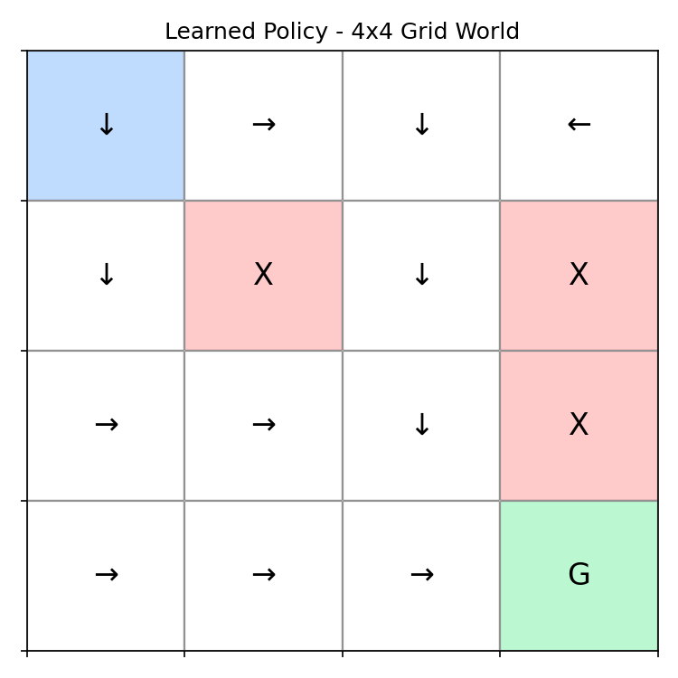
Legend: blue cell = start, green = goal, red = obstacle cells; arrows show the greedy (argmax-Q) action learned for each state.
Cumulative reward per episode
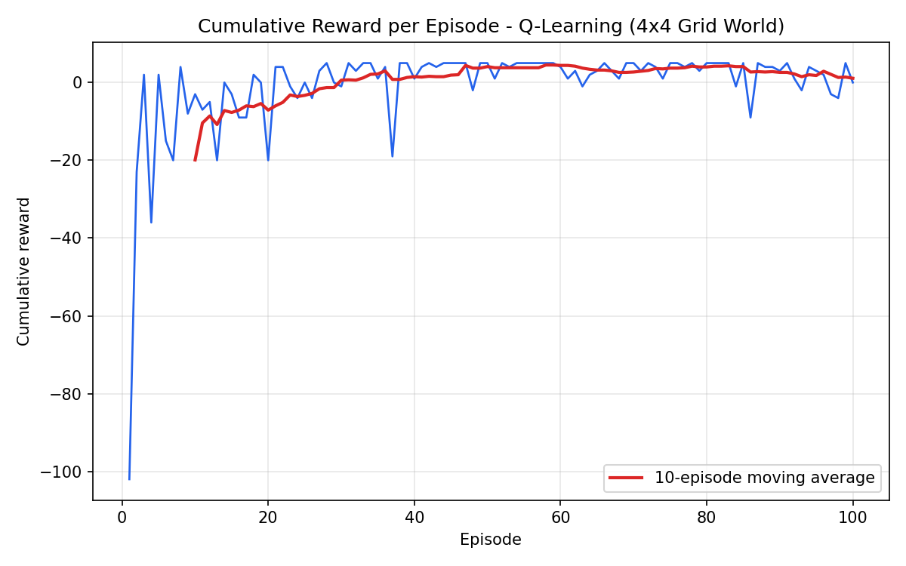

Convergence Discussion
Average reward (first 10 episodes): -19.90
Average reward (last 10 episodes): 1.10

- Early episodes show highly negative, noisy cumulative reward (average ≈ −19.9 over the first 10 episodes) because the Q-table starts at zero, so the ε-greedy agent behaves almost randomly, frequently hitting obstacles (−5) and wandering many steps (−1 each) before stumbling onto the goal.
- As episodes progress, the reward curve trends upward and its variance shrinks — visible in the plotted 10-episode moving average — because the Bellman backup repeatedly propagates the +10 goal reward backward through the states the agent visits, so Q-values for good actions rise above those for bad ones.
- By the last 10 episodes the average cumulative reward is positive (≈ +1.1), indicating the agent now reaches the goal in close to the minimum number of steps most of the time, occasionally deviating due to the fixed ε = 0.2 exploration rate (which never fully decays to 0 in this run).
- The extracted greedy policy forms a consistent path of Down/Right actions from the start toward the goal while routing around the obstacle states (5, 7, 11), confirming the agent has learned a near-optimal policy consistent with the reward structure.
- Full convergence to the exact optimal Q-values would require either more episodes and/or a decaying ε so that exploration reduces over time and the greedy policy is evaluated/updated without random disturbance.

